Computer Science Final Project

1. **Brainstorming and Proposal**

For my computer science final project, I would like to create an interactive website which has a few web pages that contain both pictures and texts. If there is enough time, I’d also like to convert my website to a mobile version. This project is worthwhile because by building an interactive website, I can learn new programming languages and apply my computer science knowledge on more visualised things. In the meantime, this project is also helpful for some kinds of communication technology, bushiness and English related assignments, such as web designing, blogging, and marketing.

In order to create an interactive website, I need to learn HTML, CSS, and jQuery. By the end of the year, I hope I will be able to code a website myself and understand the program behind each function of a website. (E.g. How’s the menu created, how does one page jump to another page when user clicks on the menu, etc.)

To be more specific, my website will be a travel blog. Since there are many traveling websites these days, my website has to be unique enough to catch readers’ attention. I can also combine this project with my English ISU, which I will be writing 3 to 4 pieces of travel blogs.

I would like to have 5 to 6 pages for my website. One home page, one destination page that allows viewers to pick the place they want to go, and 3 to 4 pages for the traveling blog. I will also apply my design skill and creativity on this project because each of the web pages needs to be appealing and unique.

Overall, this project will allow me to visualize what I have learned in class and give me the opportunity to discover the website designing field. This project also extents to concepts studied in other courses and can enhance my programming skill, communication skill, and design skill.

1. **Research**

* A software/platform to build a website:
  + Word press: already has a design format, doesn’t require much programming. Can deploy websites

https://wordpress.com/create/

* + Bracket: a platform to program websites, but doesn’t deploy websites

http://brackets.io/

* An online coding school to learn to build a website:
  + Code Academy: Has interactive courses and provides opportunities to apply learning. This website has taught me how to code a website by using HTML and CSS.

https://www.codecademy.com/learn

* + W3 Schools: This website provides more detailed HTML and CSS programming lessons. Although it is less interactive than Code Academy, it has lots of examples that demonstrate the function of each chunk of code within a program

http://www.w3schools.com/

* Website design:
  + http://editor.wix.com/html/editor/web/renderer/edit/7d6d7917-c1ad-4b40-9fef-1e3a9d3fbd33?metaSiteId=cc12f0d0-d03d-40a0-a3f8-cdf86363181c&editorSessionId=9FAA10CA-F8F4-495B-AFAE-4F6C9AF8D1C1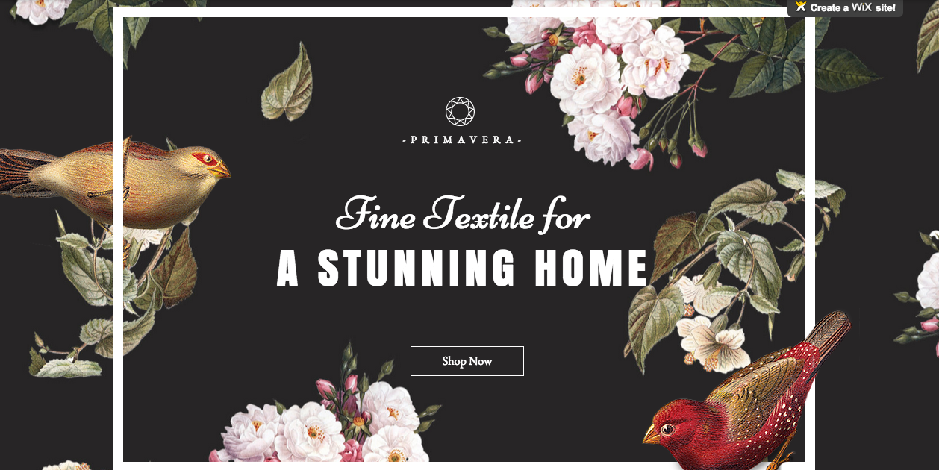
  + This website has an attractive home page design that causes viewers’ attention right away. Therefore, I decided to create a home page that contains a fascinating background, a border around the contexts, and concise titles in order to attract reader’s attention. I also decided to design a button below the title that allows the viewers to go to other web pages.

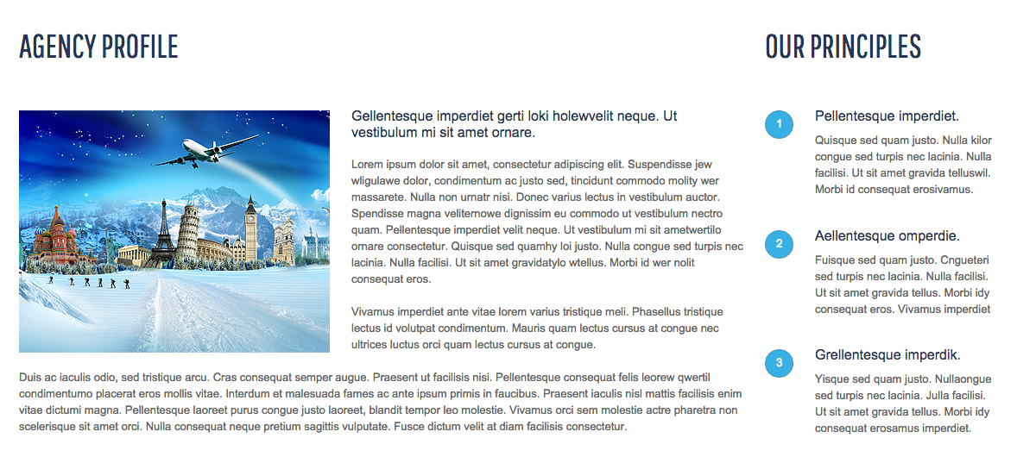

* + The format of this webpage is very simple and neat. Because it contains both pictures and short paragraphs, viewers won’t get bored while skimming through the contents. Therefore, for the “travel blog” portion of my website, I decided to use similar format in order to track people’s attention.

file:///Users/vwang/Downloads/journey/about.html

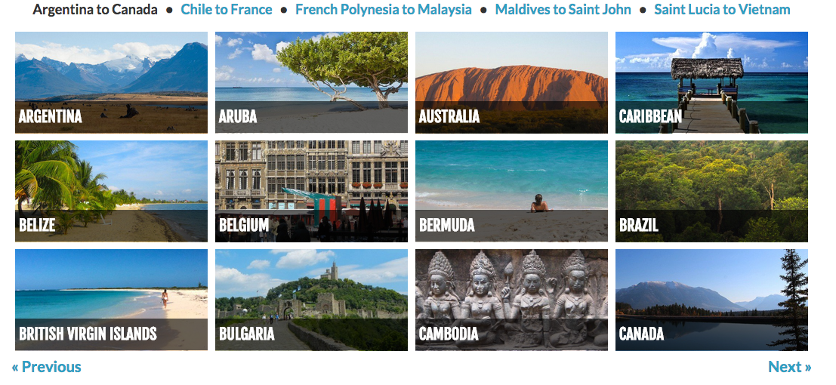

* + Since I am doing a traveling website, the number of webpage will increase as more and more travelling blogs are written. Making a menu like this is very interactive, and it is easier to add new pages.

http://www.nomadicmatt.com/travel-guides/

**5. Reflection**

My final product turned out to be a 5-page website that is programmed in HTML and CSS. Due to the limited time, I didn’t get a chance to learn jQuery or convert my website to a mobile version.

This project is completely different from what I’ve learnt in class. It is more independent, more creative, and more informative. By completing tasks on Code Academy, I got a brief view of HTML and CSS, and was able to apply what I learned on my project. Things started easy. For the first stage of my process, I only needed to use simple codes to outline the contents of my website. However, once I reached the second stage of my process, things got more complicated. For example, I had to recognize the relationship between mother class and child class in order to make the website appear in a desired style. The hardest challenge I encountered during the programming phase was probably formatting contents. Since the titles, paragraphs, footers, and images all have different size, it was hard to set the format of a webpage in order to make the style visually appealing. (E.g. Texts on the left, image on the right). To overcome this challenge, I programmed a few CSS style sheets and compared them to each other. Some of the style sheets messed up the entire format of a webpage, while others required small modifications. At last, I decided to include CSS code within HTML code so it’s easier to debug and modify the program.

The most challenging part of designing a website is debugging. After I finished a chunk of code and viewed it in browser, things didn’t always go to the way I wanted to. Therefore, I spent a long time debugging the program. For example, I located the part of the code that went wrong, read over the code and modified some numbers. However, the code was still not doing what it was designed to do sometimes. Therefore, I tested different codes with similar use in order to solve those problems.

Through these ups and downs, I was able to get a better understanding of HTML and CSS. My mistakes revealed my weakness, so that I would review the corresponding Code Academy lesson in order to enhance my understanding in each specific part. Since this project is an independent project that extents beyond traditional classroom learning, I learned to manage time wisely and self-study effectively.

Overall, this project gives me an opportunity to learn other programming languages and demonstrate my creativity and self-learning ability. What’s more, this project makes me realize the importance of trial and error and warns me to manage time wisely and not to leave everything to the last minute.